
A14
Sreenidhi Institute of Science & Technology
(An Autonomous Institution)
Code No: 4W104
M. TECH. I – Year I – Semester Examinations, March/April 2015, (Regular)
ADVANCED MECHANICS OF SOLIDS (CAD/CAM)

Time: 3 Hours Max. Marks: 60

Note: No additional answer sheets will be provided.

Part - A
Max.Marks:10

Answer all QUESTIONS.
- Write the stress tensor for general case and hydrostatic stress.
- Write the three stress invariants.
- Define the shear centre and its importance.
- Draw the distribution of shear stress across the cross-section of hallow circular shaft, square and equilateral triangular solid shafts subjected to pure torsion.
- Write the differences and similarities between straight and curved beams.
- What are the differences between brittle and ductile fractures?
- What are the limitations of Winkler Bach formula?
- Define the principal moment of inertia and write the expressions for it to hallow circular and square sections in general notations.
- What are the assumptions made and limitations of Euler’s formula related to columns?
- Briefly write the effect of sizeon fracture.
Part – B
Max. Marks: 50
ANSWER ANY FIVE QUESTIONS. EACH QUESTION CARRIES 10 MARKS.
1 (a) By applying the fictitious load method find the deflection of a cantilever beam at its midpoint when it is subjected to a uniformly distributed load of 50N/mm. Take length of the beam as 4 m, cross section of the beam as rectangle of dimensions 60 mm X 40 mm, E = 2.1x10⁵ N/mm² and G = 0.8x10⁵ N/mm².
(b) A simply supported beam is subjected to two midpoint loads W symmetrically at a distance of L/4 from the two supports. Find the deflections of the beam at the points of application of the loads by applying virtual work principle. Take EI as the flexural rigidity of the beam.
2. A curved beam with a circular centre line has the T-section as shown in fig. This beam is subjected to pure bending in its plane of symmetry. Find the tensile and compressive stresses in the extreme fibres. Take b₁ = 100 mm, b₂ = 20 mm, the radius of curvature of the innermost fibre, r₁ = 80 mm, the outermost fibre, r₂ = 180 mm and r₃ = 100 mm.
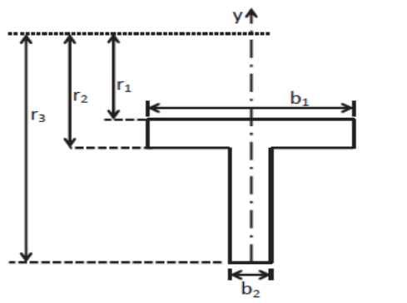

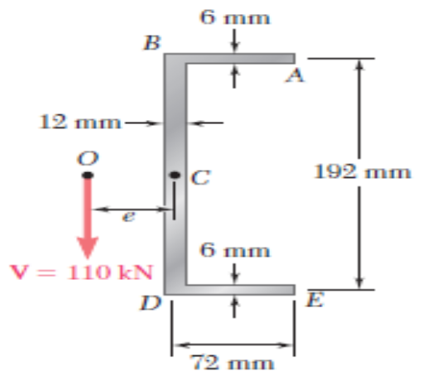
3. An extruded beam has the cross section as shown in the fig. Determine (a) location of the shear centre (b) the distribution of the shearing stresses by the vertical shearing force V applied at O.

4. (a) Briefly explain the Secant formula applied to the analysis of columns.
(b) An axial load P is applied at point D that is 4 mm from the geometric axis of the square aluminium bar BC. Using E = 70 GPa, by using the suitable formulae determine,
(i) the horizontal deflection of end C
(ii) the max stress in the column.
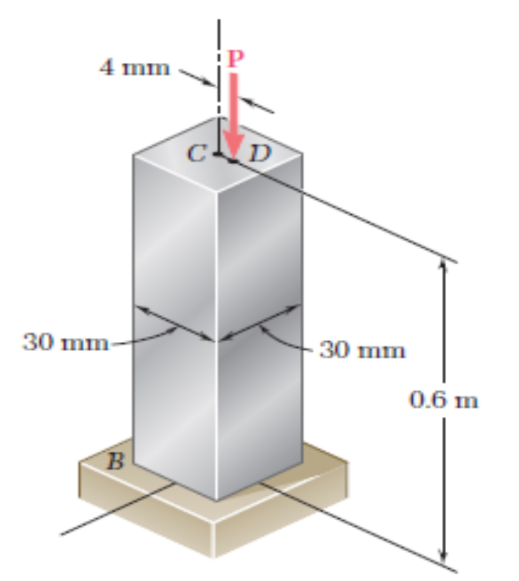
5. Derive the expression for the shear stresses in an elliptical bar subjected to pure torsion and discuss the result.
6. (a) Write about Griffith Energy Balance and also its limitations / difficulties.
(b) Compare the R- curve for plane stress and plane strain cases.
7. (a) Derive the expression for the Principal Moments of Inertia for a general cross section in standard notations.
(b) Derive the expression for the Euler’s critical load for a column fixed at both ends and subjected to axial load.
-- 00 -- 00 --

